Focus Group for App Design

|  |  |  |  |
| --- | --- | --- | --- |
|  | App Design1(Marvel) | App Design 2 ( | App Design 3 |
| Overall Design |  |  |  |
| User Experience |  |  |  |
| Ease of use |  |  |  |
| Usefulness |  |  |  |

App 1

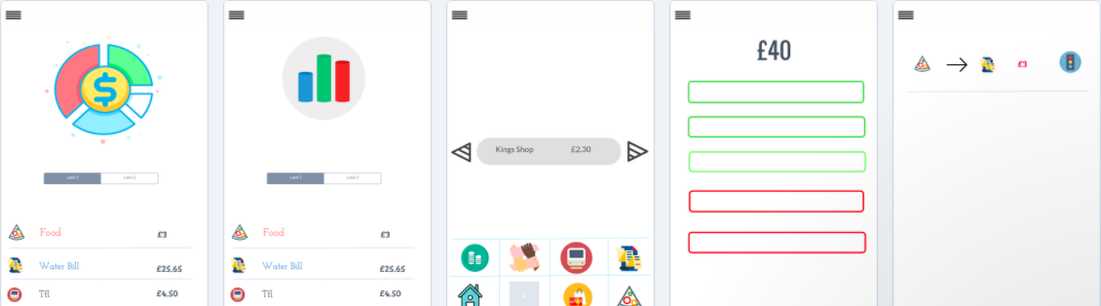

App 2

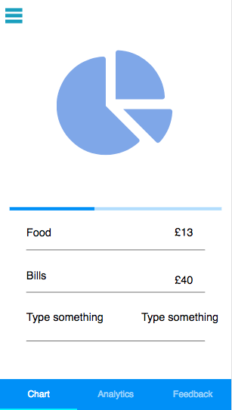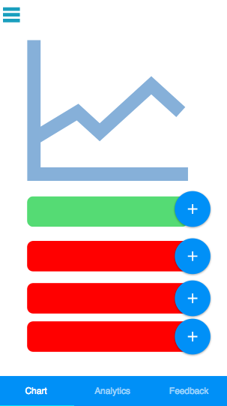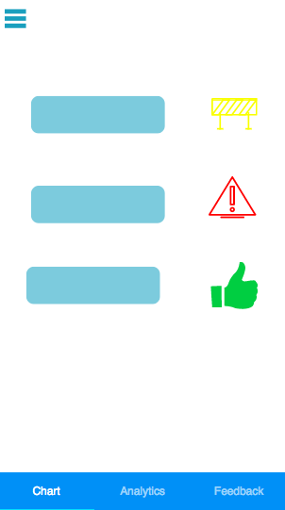

App 3

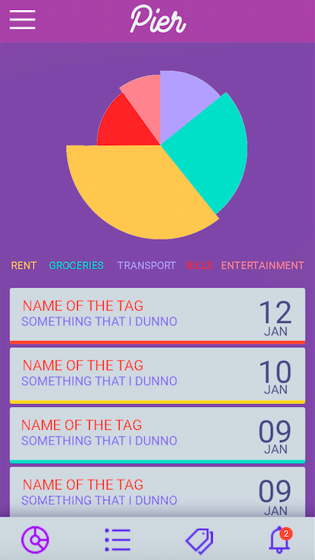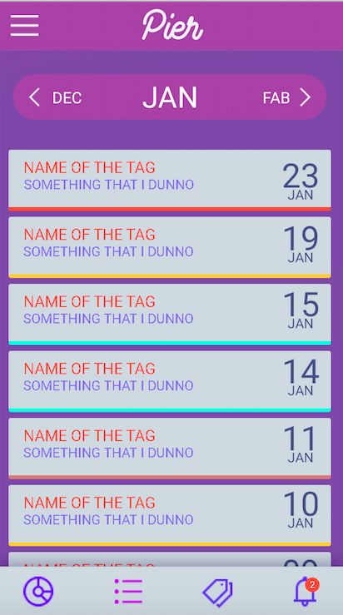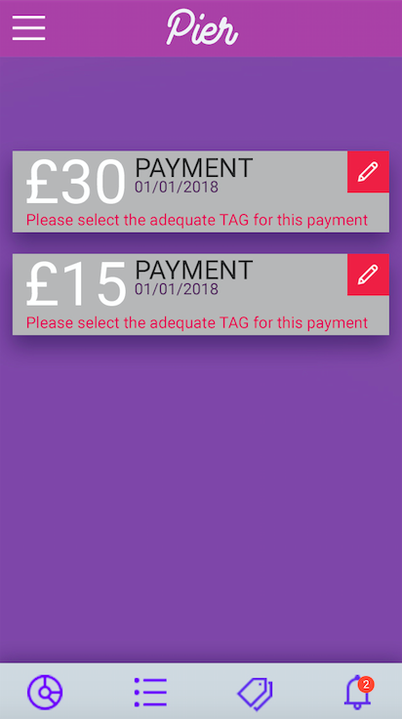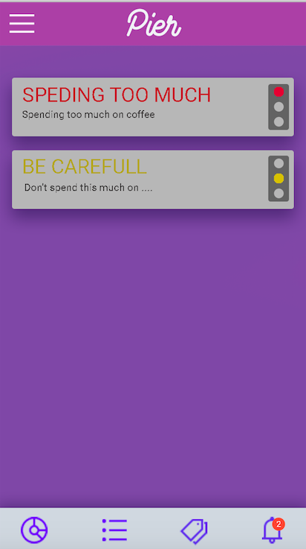

For Each function

**Breakdown –**

Which App has the best breakdown?

App 3

What would you change/add to make it better in your opinion?

Tag size

**Data Analytics -**

Which App has the best breakdown?

App 3

What would you change/add to make it better in your opinion?

-

**Tags-**

Which App has the best breakdown?

App 1

What would you change/add to make it better in your opinion?

Multiple

**Alerts**

Which App has the best breakdown?

Traffic- app1

What would you change/add to make it better in your opinion?

**Input Method**

Method 1 – Leave to side bar- 3

Method 2 – Put in tab

Any other comments/ Suggestions